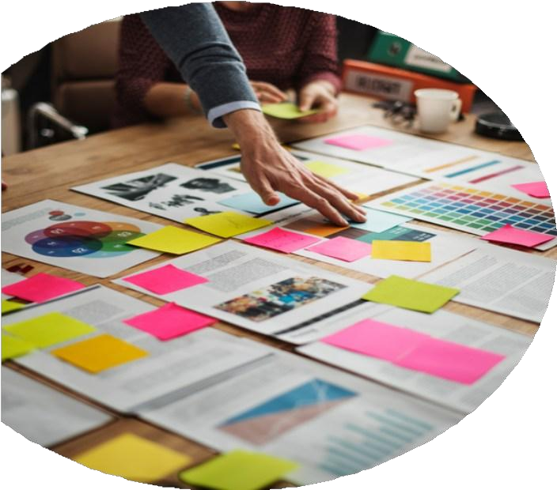

#### AI AUTOMATION CONSULTATION PROPOSAL

##### Design, Build & Scale

|  |
| --- |
| **Client Info:** |
| **Name: <<Client Name>>** |
| **Email: <<Client Email>>** |
| **Phone: <<Client Number>>** |
| **Country: <<Country>>** |

**Date: <<Date>>**

+12088421478

[info@appsynergies.com](mailto:info@appsynergies.com)

186 Malvern Avenue, Harrow, HA2 9HD, UK AppSynergies Pvt Ltd, D-1602, Orchid Suburbia, Link Road, Kandivali West, Mumbai 400067, India

2

 [www.appsynergies.com](http://www.appsynergies.com/)

Table of Contents

* Company Overview 3
* Our Services 4
* Our Approach 6
* Team Expertise 7
* Business Requirements & Project Overview 8
* Project Pricing 9
* Project Timeline 11
* Client Onboarding 12
* Terms & Conditions 13
* Client Testimonials 14
* Case Studies 15
* Contact Us 17

[info@appsynergies.com](mailto:info@appsynergies.com)

+12088421478

3

 [www.appsynergies.com](http://www.appsynergies.com/)

## COMPANY OVERVIEW



Why Us?

   

|  |  |  |  |  |  |
| --- | --- | --- | --- | --- | --- |
| **100+** | **50+** | **50+** | **100+** | **50+** | **10+** |
| **Projects** | **Apps** | **Websites** | **Happy** | **Technical** | **Years** |
| **Completed** | **Developed** | **Developed** | **Clients** | **Team** | **Experience** |

About Us

Driving Growth Through Technology and Marketing. We help businesses thrive in the digital landscape. From crafting innovative AI-driven apps and websites to executing high-impact SEO, ASO, SMM, content, and email marketing strategies, we deliver measurable results that matter.

We are a fast-growing business with a very talented and rapidly expanding team. We specialize in Design, Development, Testing, Release & Project Management of AI driven apps & websites. We also specialize in Digital Marketing Services like SEO, ASO, SMM, Content & Email Marketing.

Mission

To be a part of people's daily lives by helping them build lasting relationships in an environment of trust & respect.

Vision

To be one of the leading technology & marketing companies in the world, admired for its innovative products & services thereby contributing to a better & sustainable world.

[info@appsynergies.com](mailto:info@appsynergies.com)

+12088421478

4

 [www.appsynergies.com](http://www.appsynergies.com/)

## OUR SERVICES

App Design & Development

At AppSynergies, we build well-designed and optimized custom mobile applications with a delightful UX for both iOS and Android.

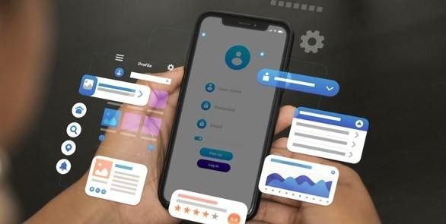 iOS Android

Flutter



 React JS

 Firebase

AI Automations

At AppSynergies, we help you to transform your business with AI & drive growth. Automate repetitive tasks, boost productivity, and make smarter decisions with our powerful AI solutions!

 AI Calling  Chatbots

Make Automations

GHL

Automations

 ManyChat Automations

[info@appsynergies.com](mailto:info@appsynergies.com)

+12088421478

5

 [www.appsynergies.com](http://www.appsynergies.com/)

Website Design & Development

At AppSynergies, we offer a complete range of website services that build up business value, from the initial idea and formulation of product strategy, through building a prototype and testing it with users, right to the creation of the product itself.



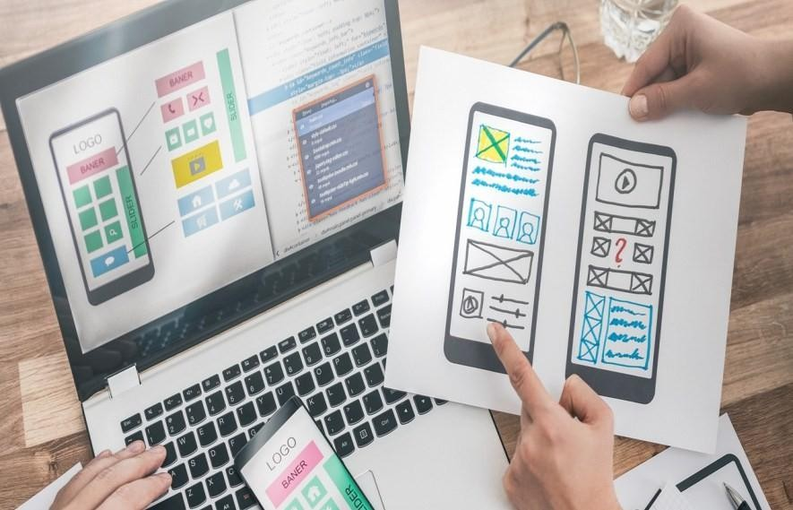Digital Marketing



Custom Website Design

E-Commerce Development

Responsive Web Design

Content Management System (CMS)

Web Maintenance & Support



We are an AI driven digital marketing agency empowering your business to innovate, optimize & grow in your market using AI-fueled marketing strategies. Our team of experts has over 5 years of experience in the digital marketing industry.

SEO

Social Media Marketing

Content Marketing



 PPC Advertising  Email Marketing

Influencer Marketing

Manual & AI Sales Service



[info@appsynergies.com](mailto:info@appsynergies.com)

+12088421478

6

 [www.appsynergies.com](http://www.appsynergies.com/)

## OUR APPROACH

###### Technical Services

* We begin by researching your industry and audience to create a tailored strategy.
* Our creative team crafts visually stunning and user-friendly apps and websites.
* We offer a complete range of technical services that build up business value.

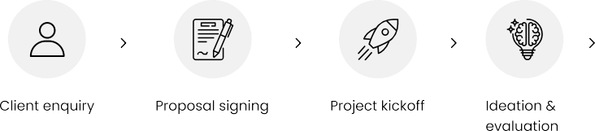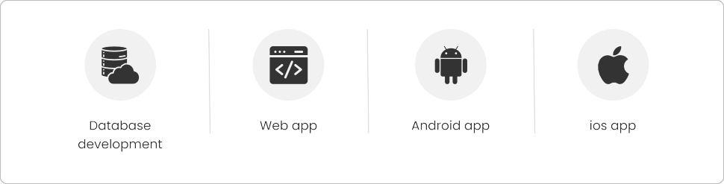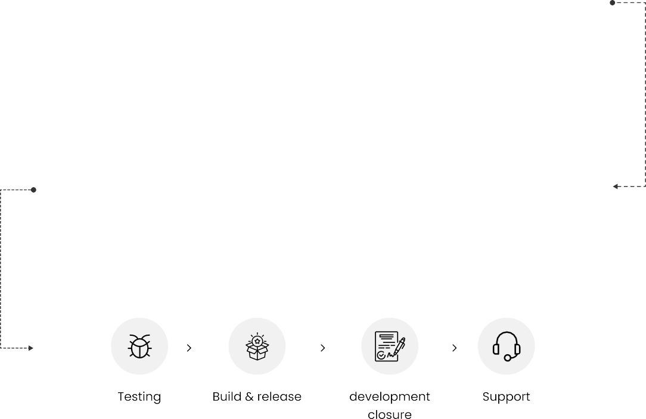

[info@appsynergies.com](mailto:info@appsynergies.com)

+12088421478

7

 [www.appsynergies.com](http://www.appsynergies.com/)

## TEAM EXPERTISE



Our team comprises of experts in various technical & marketing fields with approximately 5 - 10 years of experience & knowledge in delivering complex projects.

You will have the below list of experienced professionals working on your project:

* Project Manager: <<P1>>
* Business Analyst: <<B1>>
* UI/UX Members: <<U1>>
* Backend Developers: <<BD1>>
* Frontend Developers: <<F1>>
* AI/ML Developers: <<A1>>
* System Architect: <<S1>>
* AWS Developer: <<AD1>>



[info@appsynergies.com](mailto:info@appsynergies.com)

+12088421478

8

 [www.appsynergies.com](http://www.appsynergies.com/)

Business Requirement & Project Overview



**AI Automations**

|  |
| --- |
| * AI Calling |
| * ManyChat |
| * Make Automation |
| * CRM Automation |
| * Email Automation |
| * Calendly Setup |

**AI Calling**

1. Advanced AI Calling Solutions: Our AI-powered calling system leverages Vapi and Retell to automate customer interactions efficiently.
2. Customizable Workflows: Easily configure call scripts, responses, and actions tailored to your business needs.
3. Real-Time Analytics & Insights: Track call performance, customer responses, and engagement metrics in real time.

[info@appsynergies.com](mailto:info@appsynergies.com)

+12088421478

9

[www.appsynergies.com](http://www.appsynergies.com/)

1. Seamless Integration: Compatible with CRM, WhatsApp, and other automation tools for a smooth workflow.
2. Multi-Language Support: Supports multiple languages for a personalized customer experience across diverse regions.

**ManyChat Automation**

1. Lead Nurturing: Automate follow-ups and engage leads through personalized messages.
2. Event Triggers: Set up automated responses based on user actions or keywords.
3. Broadcast Messaging: Send announcements, updates, or promotions to your audience in bulk.
4. Drip Campaigns: Create scheduled sequences to guide users through a sales funnel or onboarding.
5. Automated Messaging: Send personalized messages, responses, and follow-ups across platforms like Facebook Messenger, Instagram, Telegram and WhatsApp.

**Make Automation**

1. Set up WhatsApp API: Integrate the WhatsApp Business API with Make Automation to enable seamless messaging and automation.
2. Connect CRM: Link CRM to Make Automation to centralize customer data and interactions.
3. Create Workflow Triggers: Set up automated workflows that trigger WhatsApp messages based on CRM actions, such as new leads, updates, or scheduled tasks.
4. Sync Data: Automatically sync customer details, conversations, and interactions between WhatsApp and your CRM to ensure up-to-date records.
5. Automate Follow-Ups: Schedule WhatsApp reminders, follow-ups, and personalized messages based on CRM activity to maintain continuous engagement.

[info@appsynergies.com](mailto:info@appsynergies.com)

+12088421478

10

 [www.appsynergies.com](http://www.appsynergies.com/)

**CRM Automations**

We specialize in automating CRM workflows and integrations with platforms like Monday.com, Notion, Zoho, Privyr and HubSpot to enhance efficiency and streamline customer management.

1. Lead Capture & Nurturing – Automate lead tracking, follow-ups, and engagement.
2. Task & Workflow Automation – Set up automated reminders, task assignments, and approvals.
3. Email & WhatsApp Integration – Send automated responses, follow- ups, and campaigns.
4. Sales & Pipeline Management – Track deals, automate forecasts, and improve conversions.
5. Analytics & Reporting – Generate real-time insights on customer interactions and sales performance.

**Email Automations**

1. Subject Line Customization – Automatically tailor the subject line based on the client's project status, ensuring clear and direct communication.
2. Client Segmentation – Prioritize emails based on the client’s project

phase (e.g., proposal, feedback, contract) to streamline responses.

1. Urgency Flagging – Set up automated rules to flag high-priority client emails, ensuring timely follow-up for urgent requests or issues.
2. Scheduled Follow-ups – Automate follow-up reminders for emails that require action, ensuring no client inquiry is overlooked.
3. Personalized Greetings & Content – Automate personalized responses based on client history, making them feel valued and improving engagement.

[info@appsynergies.com](mailto:info@appsynergies.com)

+12088421478

11

 [www.appsynergies.com](http://www.appsynergies.com/)

Calendly Setup

1. Calendly & ManyChat Integration – Connect Calendly with ManyChat via Make to automate appointment scheduling.
2. Trigger-Based Automation – Automatically send Calendly booking links to users based on predefined triggers in ManyChat.
3. Real-Time Sync – Ensure seamless syncing of booked appointments, cancellations, and reschedules between Calendly and ManyChat.
4. Automated Follow-Ups – Set up follow-up messages in ManyChat for confirmations, reminders, and post-meeting engagement.
5. Custom Data Mapping – Transfer user details from ManyChat to Calendly for personalized scheduling and data tracking.

Note:

In the initial phase we would be designing & prototyping the website/app/admin panel to show a demo of how it the flow will be and with the click of each button, what will be the situations that we would have to handle to ensure ease of use of the platform.

The points mentioned will be taken care of, feedback from the client will be our priority and depending of the feedback, situations & use cases, these features might be changed accordingly.

[info@appsynergies.com](mailto:info@appsynergies.com)

+12088421478

12

 [www.appsynergies.com](http://www.appsynergies.com/)

## PROJECT PRICING

|  |  |
| --- | --- |
| **AI Calling + CRM Integration** | **<<AI-Price>>** |
| **CRM Automations** | **<<C-Price>>** |
| **ManyChat & Make Automation** | **<<MM-Price>>** |
| **AI Content Creation** | **<<AIC-Price>>** |
| **Email Automation** | **<<E-Price>>** |
| **AI Calling (Basic)** | **<<AIB-Price>>** |
| **Annual Maintenance** | **<<AM-Price>>** |
| **Total Amount** | **<<T-Price>>** |

This annual maintenance fee covers the charges to make sure the platform is live and always running properly. If there are any live bugs or anything goes wrong with the platform then we will make sure it is fixed and deployed as soon as possible. We also regularly check & run tests on the platform to make sure everything is working fine.

|  |  |
| --- | --- |
| **Additional Features & Enhancements** | **<<AF-Price>>** |

We would be charging this amount for a team (1 BA/PM, 1 UX, 1 Dev, 1 QA) per week (5 days/40 hrs) on project work after the project completion for any ongoing enhancements, features that the client would want after release.

[info@appsynergies.com](mailto:info@appsynergies.com)

+12088421478

13

 [www.appsynergies.com](http://www.appsynergies.com/)

###### Payment Method

**AppSynergies Pvt Ltd accepts the following payment method:**

* Bank Transfer
* Credit Cards and Debit Cards
* Net Banking
* Gpay or Paytm

###### Payment Schedule

|  |  |
| --- | --- |
| **Sr No.** | **Schedule** |
| 1 | Before starting the project, the client needs to pay 30% of the total or the estimated amount. |
| 2 | On 40% project completion, the next 40% payment needs to be released. |
| 3 | Once the project gets completed the client needs to pay the rest 30% of the total amount before getting the handover. |

**Note:** We are happy to offer 10% discount if you can sing the contract & start the project withing 48 hours.

Next Steps:

Our proposal is valid for a week. To take advantage of this proposal and proceed with the project as outlined, the client next step must be to:

* Accept the proposal as-is
* Discuss desired changes with AppSynergies Pvt Ltd.
* Finalize and sign the contract
* Submit an initial payment as mentioned in the payment schedule section

Once completed, AppSynergies Pvt Ltd will connect you to schedule project launch meeting to make introductions and gather information before beginning the work.

We are happy to make changes to the project scope on your request at any time but this may be subject to additional billing.

[info@appsynergies.com](mailto:info@appsynergies.com)

+12088421478

14

 [www.appsynergies.com](http://www.appsynergies.com/)

## PROJECT TIMELINE

* 0 Week  Designs
* 2-3 Weeks  AI/ML Automations
* 1-2 Weeks  Testing & Live
* Overall Project Completion 1-1.5 Months

[info@appsynergies.com](mailto:info@appsynergies.com)

+12088421478

15

 [www.appsynergies.com](http://www.appsynergies.com/)

## CLIENT ONBOARDING



* **Initial Consultation**: We schedule a meeting to discuss your goals, needs, and expectations.
* **Proposal Presentation**: We present our tailored proposal, including pricing and project details.
* **Project Kickoff**: Once you approve the proposal, we initiate the project, assigning a dedicated team.
* **Regular Updates**: We provide regular progress updates and milestones.
* **Project Completion**: Upon project completion, we conduct thorough testing and hand over all deliverables.
* **Ongoing Support**: We offer post-launch support and assistance as needed.

[info@appsynergies.com](mailto:info@appsynergies.com)

+12088421478

16



[www.appsynergies.com](http://www.appsynergies.com/)

### Terms & Conditions

Once the project fee is paid in full to AppSynergies Pvt Ltd, any elements of text, graphics, photos, contents, trademarks, or other artwork furnished to the client for inclusion in the website are owned by the client. AppSynergies Pvt Ltd assumes the client has permission from the rightful owner to use any code, scripts, data, and reports provided by the client for inclusion in its materials, and will hold harmless, protect, and defend AppSynergies Pvt Ltd from any claim or suit arising from the use of such work.

AppSynergies Pvt Ltd retains the right to display graphics and other web content elements as examples of their work in their portfolio and as content features in other projects. This agreement becomes effective only when signed by the client and AppSynergies Pvt Ltd. Regardless of the place of signing of this agreement, the client agrees that for purposes of venue, this contract was entered into in Mumbai, India and any dispute will be litigated or arbitrated in Mumbai, India.

The agreement in this contract constitutes the sole agreement between the client and AppSynergies Pvt Ltd regarding all items included.

**This proposal shall be valid until 24/02/2025**

**Feel free to reach out to us at** [info@appsynergies.com](mailto:info@appsynergies.com) **or +12088421478 for any questions.**

**Signature Details**

|  |  |
| --- | --- |
| <<Client Name>> | Sneha Shukla |
| <<Date>> | <<Date>> |

We look forward doing business with you.

Thank You, Team AppSynergies

[info@appsynergies.com](mailto:info@appsynergies.com)

+12088421478

17

 [www.appsynergies.com](http://www.appsynergies.com/)

### Client Testimonials

**Eric**

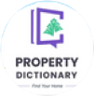

Sustainability Ledger, CEO

“Very good team with great understanding of apps. They helped me build my idea of energy estimation and management for household. Their development skills are second to none.”

**Benny C**



UCALL, CEO

“Selecting this team proved invaluable. Their professionalism, creativity, and prompt delivery greatly influenced our projects success. We’re grateful for their outstanding dedication!”

**Wai Chan**

My Wallet, CEO

“AppSynergies resolved major issues with the first version of the product, leading to sustained growth for us. Their development skills are second to none!”

**Asim**

Property Dictionary, CEO

“Working with this team was easy and fun. They really know their stuff, and our project turned out way better than we hoped. Looking forward to more projects together!”

**Ankur**

Edlighten, CEO

“They helped us build a psychometric test platform & AI ML Models which helped us analyze the thinking skills of students.”

**Musa**

Hola Home, CEO

“They developed a property booking platform for us. Very fast setup, good team work and handover by their side.”



[info@appsynergies.com](mailto:info@appsynergies.com)

+12088421478

[www.appsynergies.com](http://www.appsynergies.com/)

18

## CASE STUDIES

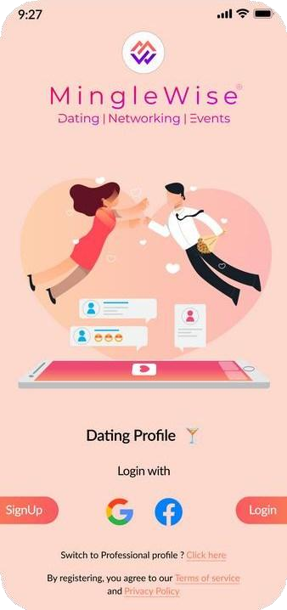

Deliverables

* **Technical Stack**
  + App: Flutter
  + Backend: Node JS,

Firebase

* + Admin Panel: Flutter
* Integrated AI for matchmaking, profile verification,

and event recommendations.

Worlds first all-in-one AI driven app for dating,

networking.



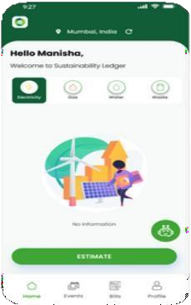

Deliverables

* **Technical Stack**
  + App: Flutter
  + Backend: Firebase
  + Admin Panel: Flutter

•

analytics, carbon tracking,

Sustainability Ledger is an app that helps household

and small business track their resource usage.

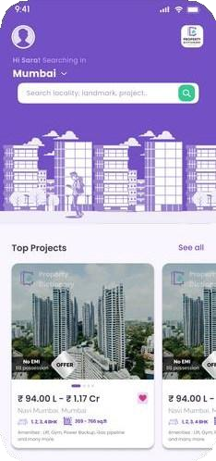

Deliverables

* Technical Stack
  + App: Flutter
  + Backend: Firebase
  + Admin Panel: Flutter
* Developed a property search app with curated listings, advanced filters, virtual tours, direct inquiries, and real-time

notifications.

Property dictionary is your go-to property dictionary

app, offering a collection of listings with comprehensive details.

 [www.appsynergies.com](http://www.appsynergies.com/)

19

CASE STUDIES



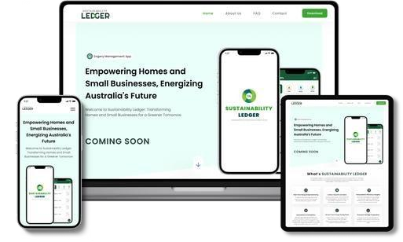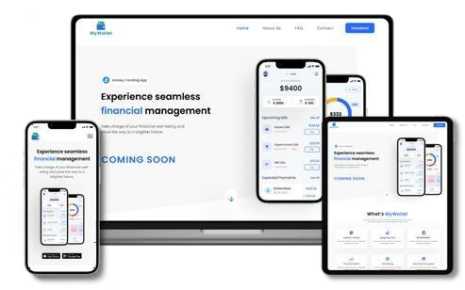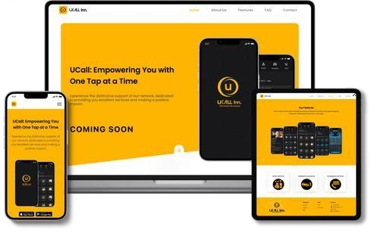

**Revolutionizing homes and small businesses for a more Sustainable tomorrow.**

* Real Time Energy Usage Monitoring
* Carbon Footprint Calculator
* Personalized Efficiency Insights
* Financial Savings Projections

**Take Control of Your Finances with Our Money Tracking App!**

* Expense Tracking
* Budget Management
* Income Analysis
* Financial Report

**Top-notch Services to users and assist in identifying the most fitting job opportunities for you.**

* + Access to Basic Services
  + Roadside Assistance Anywhere
  + Emergency Services at Your Call
  + Book any Service & get rapid response

[info@appsynergies.com](mailto:info@appsynergies.com)

+12088421478

20



 [www.appsynergies.com](http://www.appsynergies.com/)

# Contact Us

**Website** <https://appsynergies.com/>

**Phone** +12088421478

**Email** [info@appsynergies.com](mailto:info@appsynergies.com)

**Social Media**

 **Address** 186 Malvern Avenue, Harrow, HA2 9HD, UK.

D-1602, Orchid Suburbia, Link Road, Kandivali West, Mumbai 400067, India.

[info@appsynergies.com](mailto:info@appsynergies.com)

+12088421478